 | - IP addressing and file transfer commands

Name of Student | Hardik Prajapati | Roll No. | 9152
Sign here to indicate that you have read all relevant material provided /available on Moodle while performing and writing this experiment |  | Sign:

Late Submission Details (if any)
Reason(s) of late submission | Date of practical performance | Date of practical submission

References used
1 | Name and author of reference book(s) with page nos.
2 | Name and roll nos. of the peers whose help you have taken (if any)

Rubrics for assessment of Experiment:
Indicator | Poor | Average | Good
Timeliness  Maintains Experiment deadline (3) | Experiment not done (0) | One or More than One week late (1-2) | Maintains deadline (3)
Completeness and neatness  Complete all parts of Experiment (3) | N/A | < 80% complete (1-2) | 100% complete (3)
Originality  Extent of plagiarism (2) | Copied it from someone else (0) | At least try to implement but could not succeed (1) | Implemented (2)
Knowledge  In depth knowledge of the Experiment (2) | Unable to answer any questions (0) | Unable to answer few questions (1) | Able to answer all questions (2)

Assessment Marks:
Timeliness
Completeness and neatness
Originality
Knowledge
Total

Signature of Teacher with date

1. | Course, Subject & Experiment Details

Course & Branch | T.E. (ECS) | Estimated Time | 02 Hours Per Week
Current Semester | Semester VI | Subject Name | Linux Server Administration
Chapter No. & Unit | 3.2 | Chapter Title | Network Management
Experiment Type | Software Performance | Subject Code | ECL 604

2. | Aim & Objective of Experiment
- To study various Linux commands for IP address configuration
- To study various Linux commands for data transfer
3. | Expected Outcome of Experiment
- To understand various Linux commands for IP address configuration and data transfer.
4. | Brief Description of the experiment

- Do the following tasks using appropriate commands:

- Change the hostname as your group no.
- Check and note ip address of your system.
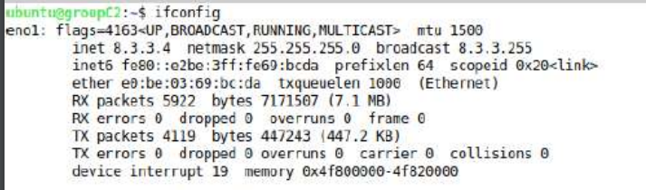
- Install SSH services on your system
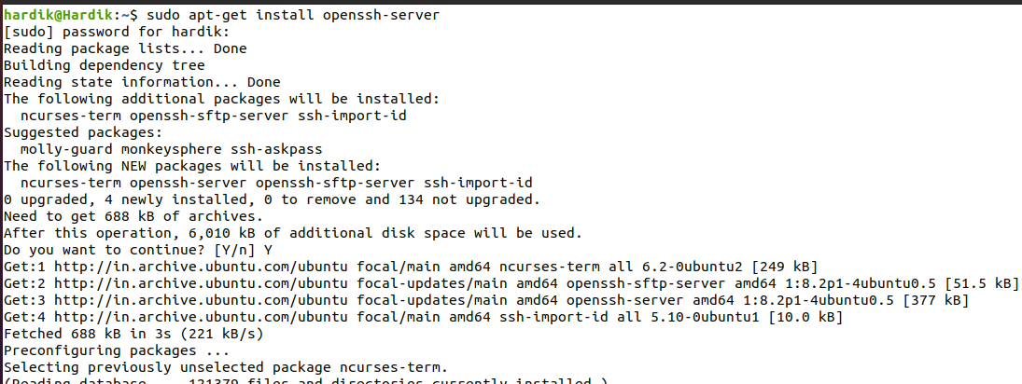

- Change the ip address of your system as per given instructions
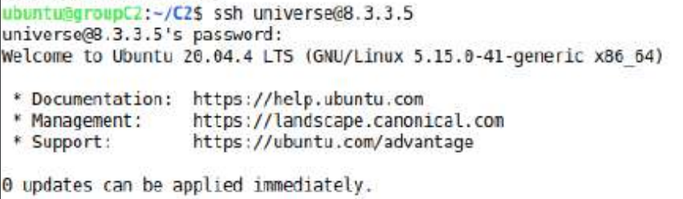
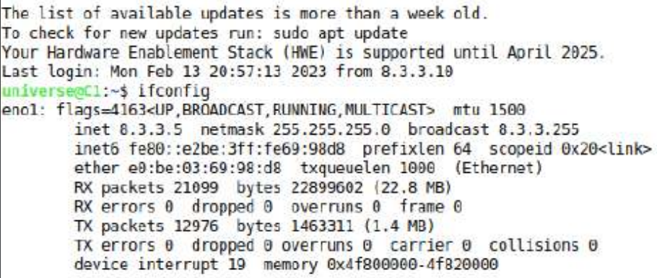

- Connect to remote system using SSH as per given instructions
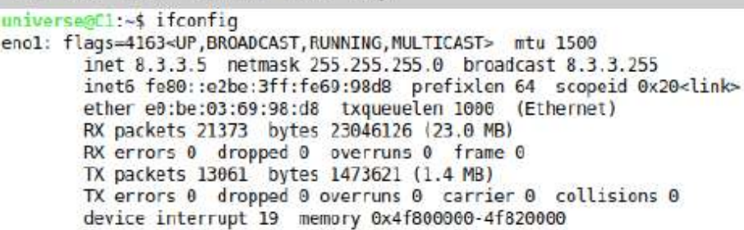

- Make sure that you are connected to remote computer.
- Close SSH session.

- Create a directory of your group number on your system
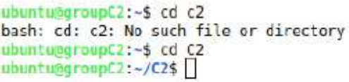

- Copy program 1 to /home/universe patrician of remote computer as per given instructions using appropriate commands
- Copy the entire folder, that you have created above to /home/universe patrician using appropriate commands.
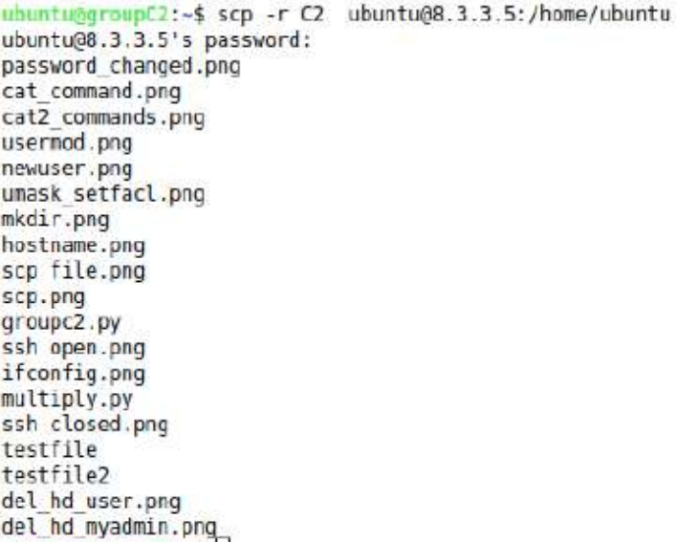
- Install “vsftpd” package on your computer.
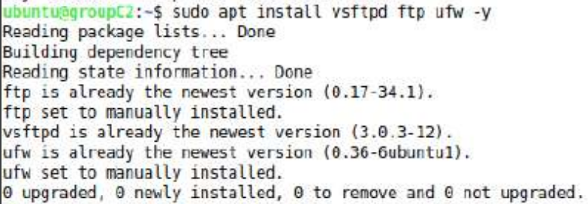

- Connect to remote host using appropriate commands of ftp.
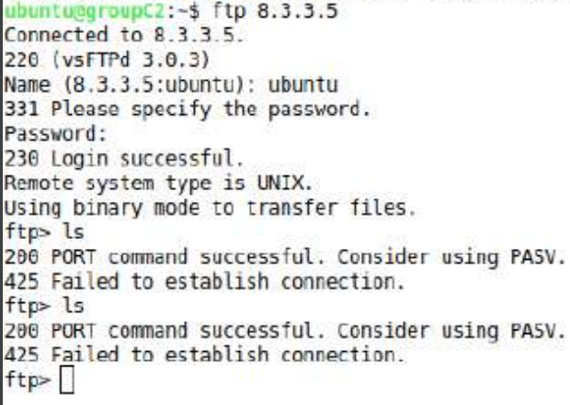
- Verify the result

Attach screenshots of output:

5. | Conclusions & Inferences

I learnt about various techniques to connect two computers using protocols like ssh , ftp , scp etc.
I also connected two remote machine using Linux command prompts

6. | Post Lab exercise

- Write a note on VNC server for remote connectivity .

